**NAME; __________________________________________________________**

**STREAM;________________________________________________________**

**PHYSICS**

**Paper 1**

***April 2024***

END OF TERM I EXAMINATIONS

**S.2 PHYSICS**

TIME ; 1.5 HOURS

**INSTRUCTIONS**

* *Write your name and the stream clearly.*
* *This paper consists of 3 compulsory scenario questions*
* *Answers are to be written on the answer sheets provided.*
* *Silent and non-programmable calculators may be used.*
* *NEAT WORK IS A MUST, poor and unreadable handwriting will lead to automatic loss of marks.*

1. In the upcoming city of Nakasongola, a group of ambitious youths has embarked on a journey to establish a modern unisex salon, thanks to a grant from the Parish Development Model. With a vision to provide exceptional service to their community, they have equipped their salon with essentials such as three big mirrors, two chairs, a bulb, shelves, and a counter. However, the challenge arises in obtaining a layout to allow customers to see multiple images of themselves simultaneously.

**Task**

a) Advice this youth group on how best they can arrange their mirrors in order to get multiple images of customers. (10 marks)

b)Determine the angle they have to incline any of the two mirrors in order for the customer to see 3 images (05marks)

c) Suppose a customer is 2cm from one of the mirrors, what is the distance between him and his image. Give a reason for your answer (05marks)

2. Nimule District, like many other regions, faces challenges related to residential comfort due to varying climatic conditions. One common issue faced by families in Nimule District is the discomfort caused by high temperatures during the night. This discomfort not only affects the quality of sleep but also impacts overall well-being and productivity.

**Task**

a) Advice families in Nimule district on the measures they can take to ensure reduced temperatures in the house during the night hours (10marks)

b) Suppose the room temperature on a particular day is 400c, calculate the corresponding temperature on a kelvin scale (4marks)

c)On a visitation day,a gate man in the same district measured the temperature of a parent and he obtained a reading of 5cm from the bulb of the thermometer. If the lower and the upper fixed points of the same thermometer are at 3cm and 10 cm respectively from the bulb. Determine the temperature of the parent in degrees Celsius . (6marks)

3. The school director wants to pave a volley ball pitch measuring 500cm by 100cm. To achieve this, he intends to use pavers sized at 5cm by 4cm. However, he is puzzled because he doesn’t know how many pavers he would need to cover the entire pitch.

**support**

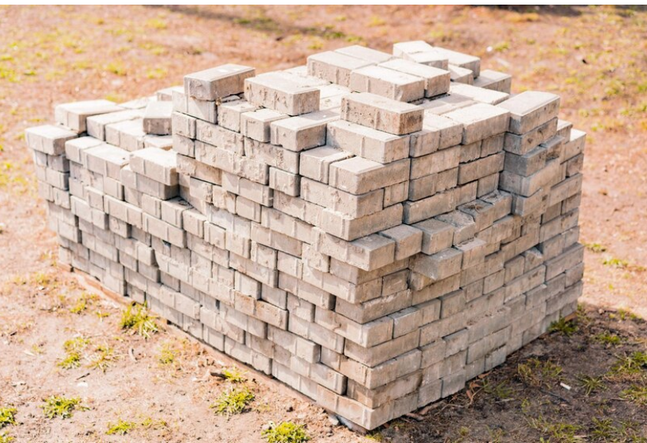

**Task**

a) Help the school director to know the number of pavers he will need for the entire volley ball pitch (10marks)

b) Convert the

(i) Area of each paver to m2 (3marks)

(ii) Area of the volley ball pitch to m2 (3marks)

c) If each paver costs shs 200, how much will he spend on buying the pavers for the entire volley ball pitch (4marks)

**Good luck**